Hospitality Option | Price starting from: | Table | Pre-match Q&A with squad | Reserved Match Seating | Food | Additional Perks
County Suite | £26.40 (excluding ticket) | Per person | ❌ | ❌ | Two-course carvery
Exeter Suite | £1000 + VAT | 10 people | ✅ | ✅  Premium West Grandstand | Gourmet two course meal | Entry into the Guess the Score Quiz (win a signed ball)
Chiefs Suite | £1200 + VAT | 10 people | ✅  + Post Match Coach Q&A | ✅  Outside the suite | Gourmet two or three-course meal  With tea or coffee | Entry into the Guess the Score Quiz (win a signed ball)

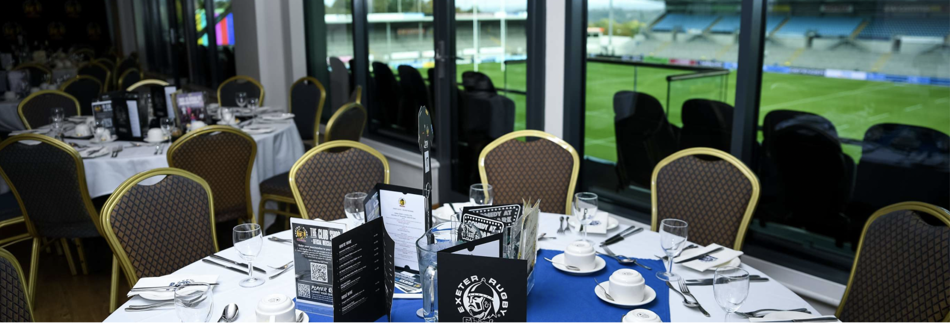

Business Gold Card (Enhanced Season Ticket) - £4200
- Entertain up to 4 people at all home matches (Men’s, Women’s, Academy)
- 4 West Grandstand tickets per game
- Exclusive bar in The Gold Card Suite
- Can also opt to book a two-course pre-match meal, with a pre-match Q&A with players
- Discounts: 5% off at all food & drink outlets, 10% in the Club Shop
- Benefit from preferential rates at Sandy Park Conference & Banqueting Centre
- New: members receive an invitation for two Gold Card Business Club events (to watch team run, network with other businesses, and e

